IT/CS Workshop (ICW) USER MANUAL

Introduction
The IT/CS Workshop (ICW) is a web based authoring system designed for use by teachers in the education field. The main purpose of the system is to create a new paradigm of computer-aided learning. The system will work by creating a course page with information such as text, videos, audio etc. which will be exported as a course page for use by the students. The authoring system for the course page will have the ability to upload various content such as inline equations, the ability to upload video, audio and the ability to link to other course pages. The overall goal of the system is to revolutionize the way in which students are taught, they will no longer be fed information without an analytical background instead they will be taught about what, when, where and why they are being taught the information.

Getting Started
The user will begin by logging on to the system website: icw.cise.ufl.edu. Before the user can use any of the website’s features they will have to create a user account.

Creating a User Account
The user will need to enter their first and last name followed by their email. They should also enter a unique user name and password which will be required every time the user is logging in. After entering this information the user must ensure that they check the box which says admin if they which to edit course content.
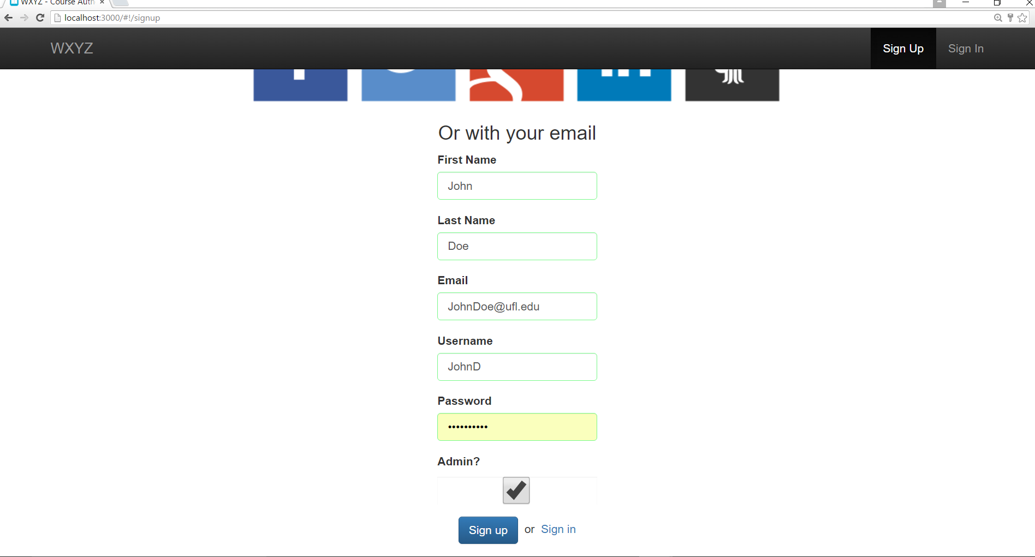Figure 1-Shows how to create a user account

Creating a New Project
The system will work by allowing the user to create projects under which they will be able to create different courses. In order to create a project they will simply click at the top left of the page, File-New and a new project will be open where they can enter a project title and a description for the project.
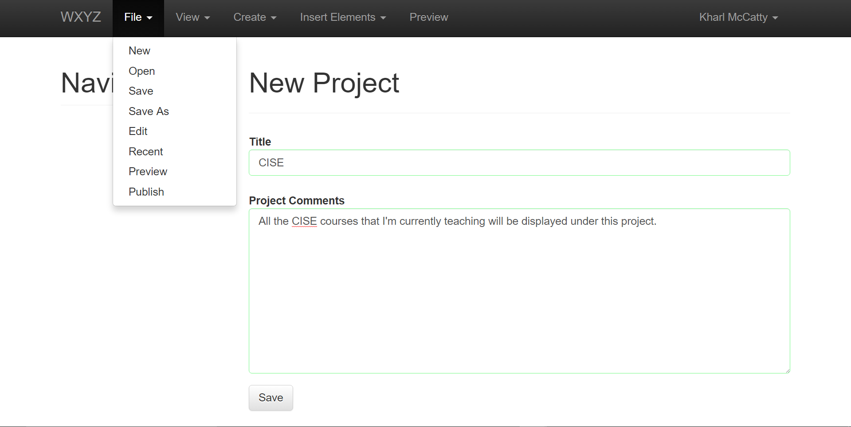Figure 2-Shows the user how to create a new Project

